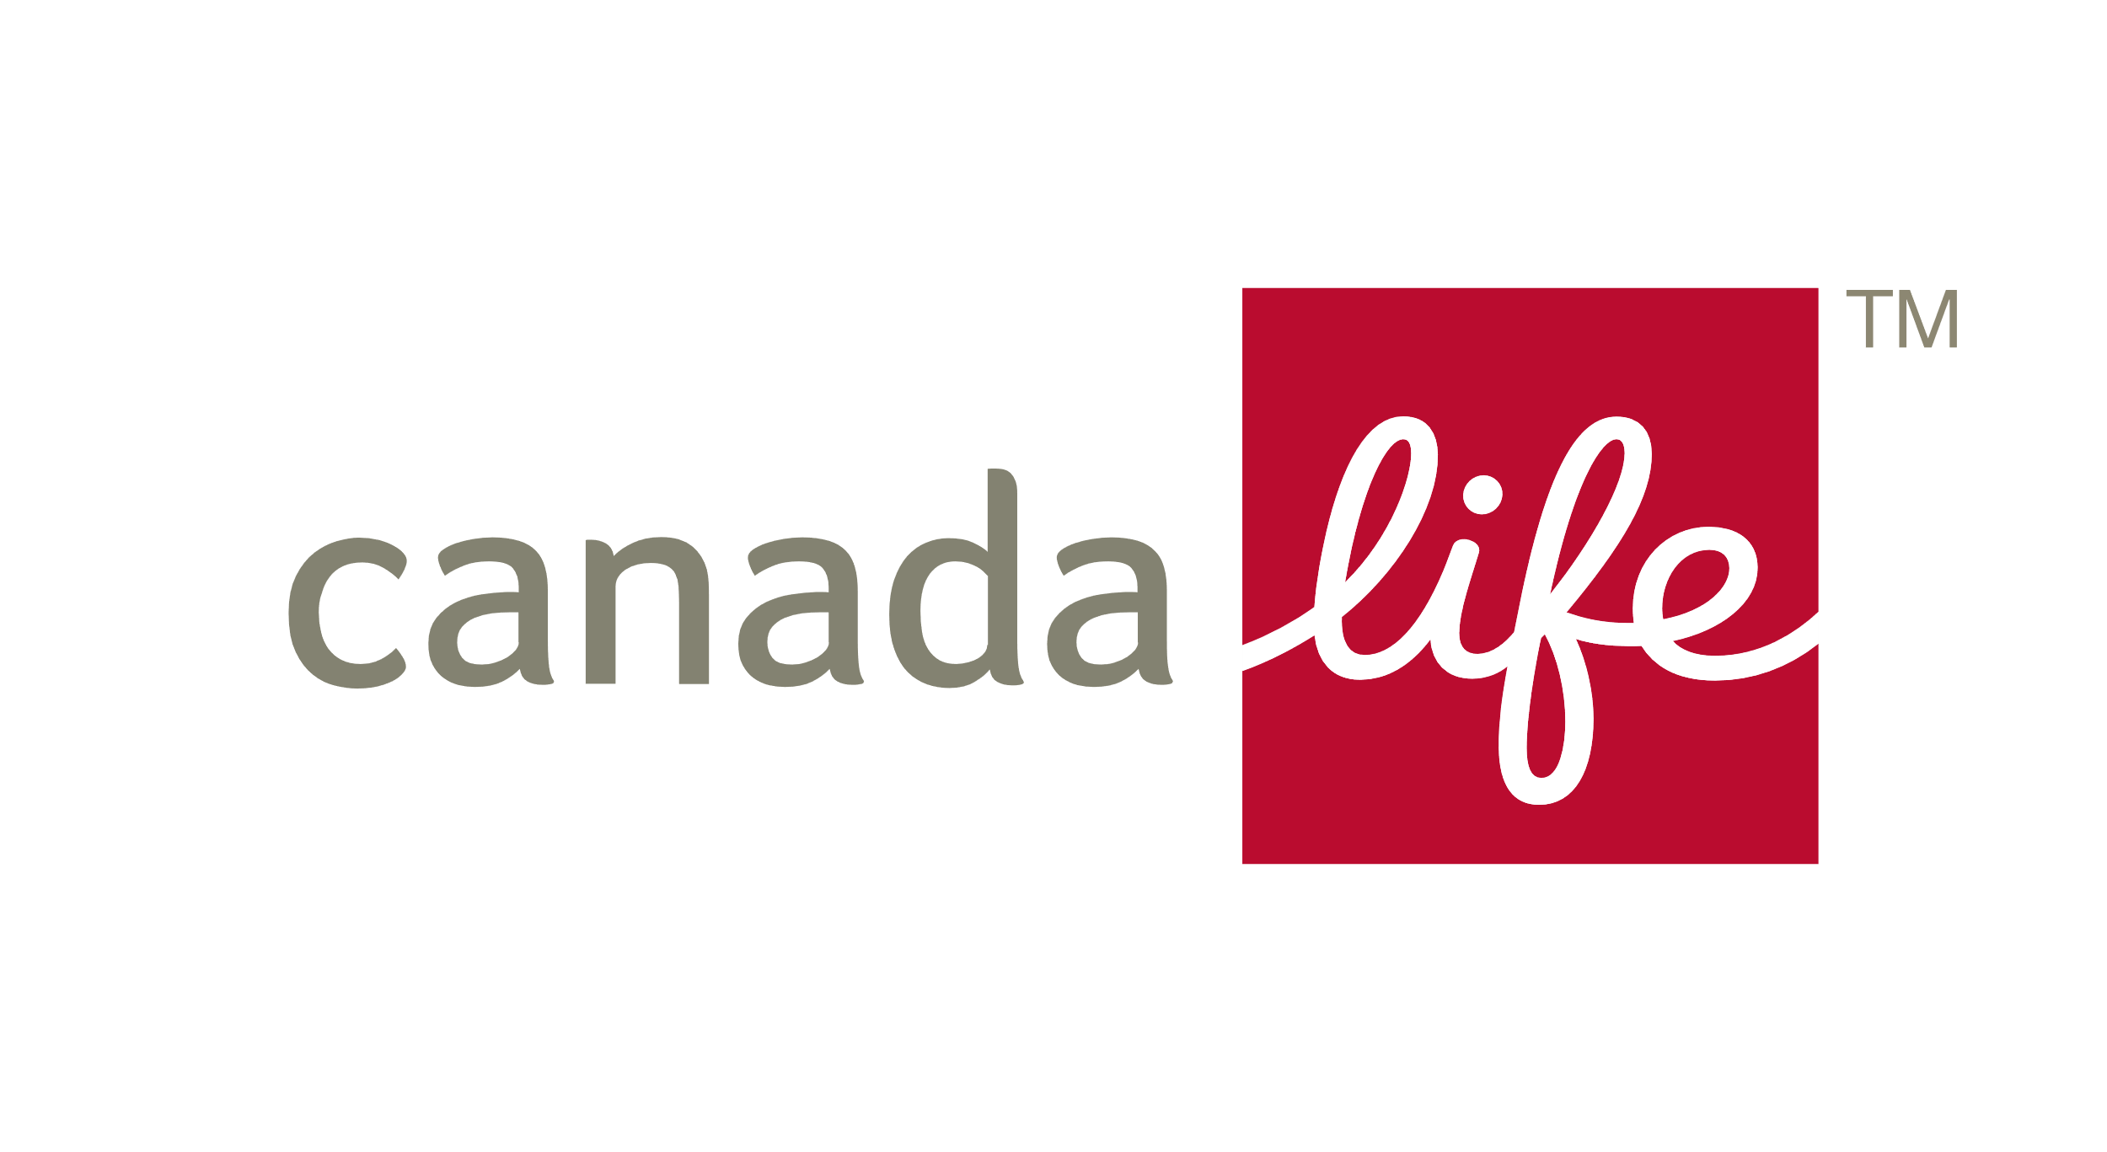

**1.**

**4. Financial Ratings**

Canada Life holds strong financial ratings through their parent company, so you can rest easy when taking out a policy. They are wholly owned by The Canada Life Assurance Company.

**Canada Life Financial Ratings**

1 Canada Life MI 2023



**Recommendation Report**

**6. Customer Support**

**5. Support Services:**

**More than just a financial benefit**

**4. Financial Ratings**

**2. Market Position**

**3. Awards**

**1. Background**

A.M. Best Company: A+

DBRS Limited: AA

Fitch Ratings: AA

Moody’s Investors Service: Aa3

Standard and Poor’s Rating Services: AA

**3. Awards**

Canada Life Group Insurance’s products are [**award winning**](https://www.canadalife.co.uk/news/canada-life-insurance-reflects-on-our-2017-in-numbers). They might be big,

but that doesn’t stop them paying attention to the small things. They continue to win prestigious industry awards for their unique approach to group insurance.

**2. Market Position**

Canada Life Group Insurance is the [**largest**](http://documents.canadalife.co.uk/2017-in-numbers.pdf) [**provider of group insurance**](http://documents.canadalife.co.uk/2017-in-numbers.pdf)in the UK. They support over 27,000 employers, covering over 3 million employees for over

£374 billion of benefits.1

**Background**

[**Canada Life Group Insurance**](https://www.canadalife.co.uk/group-insurance)is the UK’s largest provider of group insurance. They have over 50 years’ experience covering thousands of businesses throughout the UK.

Established over 175 years ago, Canada Life sold their first policy in 1847. Moving to the UK in 1903, Canada Life now have offices throughout the UK, Canada and Europe, specialising in a wide range of financial services, from insurance to pensions.

With a mission to help people when they need it the most, they specialise in three products that help employers do exactly that – [**Life Assurance**](https://www.canadalife.co.uk/group-insurance/group-life-assurance), [**Income Protection**](https://www.canadalife.co.uk/workplace-protection/group-income-protection/)and [**Critical Illness**](https://www.canadalife.co.uk/group-insurance/group-critical-illness)cover.

1 These services are non-contractual benefits provided through Canada Life and can be altered or withdrawn at any time.

2 Canada Life MI 2023.

**Experienced claims management teams – Claims paid quickly and sensitively**

**Dedicated Trust Deed webpage – Sample Trust Deeds and helpful information**

**Employee engagement tools – Videos, guides, flyers and more**

**5. Support Services: More than just a financial benefit**

**Canada Life believes insurance is about much more than just a financial benefit.**

That’s why each of their products includes a range of [**Support Services**](https://www.canadalife.co.uk/group-insurance/support-services),1 to further strengthen your employee benefits package. These services include [**Bereavement**](https://www.canadalife.co.uk/group-insurance/group-life-assurance/bereavement-counselling) [**Counselling**](https://www.canadalife.co.uk/group-insurance/group-life-assurance/bereavement-counselling), [**WeCare**](https://www.canadalife.co.uk/workplace-protection/support-services/wecare/), our [**Toothfairy**](https://www.canadalife.co.uk/workplace-protection/support-services/toothfairy/)and [**myStrength**](https://www.canadalife.co.uk/workplace-protection/support-services/mystrength/)apps, and a [**Second Medical**](https://www.canadalife.co.uk/group-insurance/group-income-protection/second-medical-opinion) [**Opinion**](https://www.canadalife.co.uk/group-insurance/group-income-protection/second-medical-opinion)service.

**6. Customer Support**

Canada Life’s support extends past just setting up the cover. Last year, they paid 99.5% of claims, with claims being paid in 10 days or less on average.2

**+** [**Experienced claims management teams**](https://www.canadalife.co.uk/workplace-protection/group-life-insurance/claims/)– Claims paid quickly and sensitively

**+** [**Dedicated Trust Deed webpage**](https://www.canadalife.co.uk/workplace-protection/trusts/)– Sample Trust Deeds and helpful information

**+** [**Employee engagement tools**](https://www.canadalife.co.uk/technical-support/?sort=upcoming&page=1&pageId=2712)– Videos, guides, flyers and more

**CLASS only**

Canada Life Limited, registered in England and Wales no. 973271. Registered office: Canada Life Place, Potters Bar, Hertfordshire EN6 5BA. CLFIS (UK) Limited, registered in England and Wales no. 04356028 is an associate company of Canada Life Limited.

Registered Office: Canada Life Place, Potters Bar, Hertfordshire EN6 5BA

Canada Life Limited is authorised by the Prudential Regulation Authority and regulated by the Financial Conduct Authority and the Prudential Regulation Authority. Canada Life and design are trademarks of The Canada Life Assurance Company.

GRP1817–0224R

**Life Insurance**

**Income Protection**

**Critical Illness**

**WeCare**

**myStrength**

**ToothfairyTM**

**Early Intervention Service**

**Second Medical Opinion**

**Personal Nurse Service**

**Bereavement Counselling**

**Probate Helpline**